FLIGHT BOOKING
IIHT

Contents
1 Problem Statement 2
2 Application Architecture 2
2.1 Microservice Architecture (Compute and Integration/Presentation/Networking and Content Delivery): 2
3 Cloud Architecture 3
4 Tool Chain 3
5 Business Requirements: 4
6 Proposed Rest Endpoints to be exposed 5
Rest APIs: 5
7 Key Rubrics/Expected Deliverables 5
8 Platform 5
9 Methodology (Agile) 6

Problem Statement
Build a software system which lets user search for a Flight Ticket and book it & includes Admin related activities. User can also cancel or update the Ticket. Below are the different roles, which need to be supported by above Software System.
- User
- Admin
The scope includes developing the application using tool chain mentioned below.

Application Architecture

Microservice Architecture (Compute and Integration/Presentation/Networking and Content Delivery):
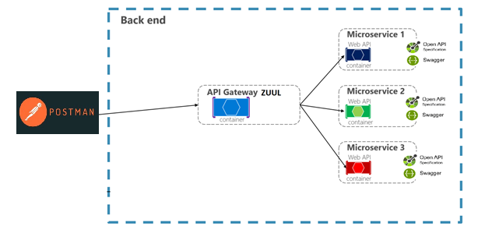

Cloud Architecture
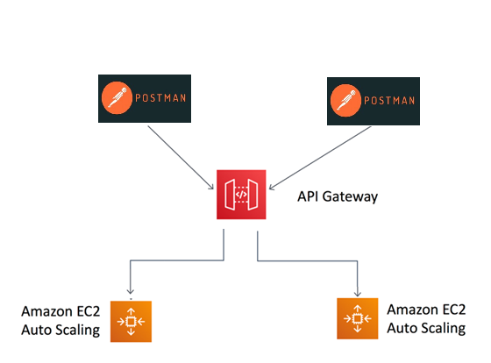

Tool Chain
Competency | Skill | Skill Detail
Engineering Mindset | Networking and Content Delivery
 | DevOps
 | Code Quality | Sonar
Programming Languages | Application Language | Java
Products & Frameworks | Presentation | Postman, Rest Client
 | Networking and Content Delivery | Zuul, SpringCloudGateway
 | Compute & Integration | Spring Boot
 |  | Reactive Spring, WebFlux
 |  | Kafka
 | Database & Storage | MongoDb
 | Governance & Tooling | Git
 |  | Junit
Platform | Cloud Tools | AWS EC2
 | Database & Storage | AWS DynamoDb
 | API proxy | AWS API Gateway

Business Requirements:
As an application developer, develop microservices with below guidelines:
User  Story # | User Story Name | User Story
US_01 | User Mode | - User registration/login not required.  - User should be able to search for flight based on date/time, from place/to place, one way or round trip  - Search result should contain date & time, airline name & logo, price, from & to and round trip (if selected)  - Using search result, User should be able to book ticket by providing below details  - Flight number  - Date and time  - From place and To place  - Name and Email ID (who is booking ticket)  - Number of seats to book.  - Details of each passenger (who will travel)  - Name  - Gender  - Age  - Meal type (Veg/Nonveg)  - Once ticket booking is complete, random unique PNR should be generated.  - User should be able to  - search ticket by providing PNR number  - search tickets by providing email id (who has booked ticket)  - cancel ticket if departure time is more than 24 hrs.
US_02 | Admin Mode | - Admin shall be able to login/logout. Registration is not required.  - There should be pre-defined username/password for Admin.  - Admin shall be able to add/edit flight to an existing airline by specifying below details:  - Flight number  - Airline  - From Place  - To Place  - Start date time  - End date time  - Meal (veg, nonveg)  - Admin should be able to add/block/unblock airline.  - Flights belonging to blocked airlines, should not be available in the ticket search results.  - When admin blocks an airline, all users (who have already booked tickets for same flight) should get notification via mail about the flight cancellation. (Implement using Kafka and Lambda)

Proposed Rest Endpoints to be exposed

Rest APIs:
POST | /api/v1.0/ airlines | Create new airline
POST | /api/v1.0/admin/login | Admin login
POST | /api/v1.0/flight/search | Searches for flight
POST | /api/v1.0/flight/booking/{flightid} | Book ticket
GET | /api/v1.0/flight/ticket/{pnr} | Get Booked ticket details based on PNR
GET | /api/v1.0/flight/tickets/{emailId} | Get booked tickets history based on Email ID
DELETE | /api/v1.0/flight/cancel/{pnr} | Cancel a booked ticket
Note: You are flexible to add/edit endpoints based on the requirements.

Key Rubrics/Expected Deliverables
As an application developer:
  - Build reactive applications using spring WebFlux.
  - Develop the application as a microservice architecture.
  - Ensure package Structure for project is like com.flightapp.* with proper naming conventions for package and beans.
  - Use application.properties or yaml file to maintain all spring boot config.
  - Implement Repository Pattern
  - Use Swagger definition
  - Use Postman to invoke API's
  - Implement API versioning
  - Implement 12Factor principles
  - Unit Test the API
  - Use Java 8 new features for implementation

Platform
      - Use Amazon API Gateway to route requests to the endpoints of the internal microservices.
      - Use DynamoDb as a database for the Application.
      - Use EC2 to deploy application on cloud.

Methodology (Agile)
- As an application developer, use project management tool along to update progress as you start implementing solution.
- As an application developer specify the estimation and planning as a part of Agile process.
- As an application developer, the scope of discussion with mentor is limited to:
  - Q/A
  - New Ideas, New feature implementations and estimation.
  - Any development related challenges
  - Skill gaps

